Uitreksels / Extracts:

1

*A Memory*

**Opgedra aan Courtney Pieters**

**Dedicated to Courtney Pieters**

And also dedicated to all the children of South Africa

En ook opgedra aan al die kinders van Suid-Afrika

An arrangement for

Unison & SSA choirs (+ optional ensemble)

‘n Verwerking vir

Eenstemmige & SSA kore (+ opsionele ensemble)

Song / Lied: WB Bradbury

Text of the song / Teks van die lied: A Warner

Main melody on the piano / Hoofmelodie op die klavier:

Frederick Chopin, Piano Sonata No.2 in B♭minor Opus 35

Arrangement / Verwerking: Salóme Hendrikse

ISBN: 978 – 0 – 6399262 – 1 – 6

Copyright regarding the arrangement / Kopiereg tov die verwerking:

Salóme Hendrikse

1

2

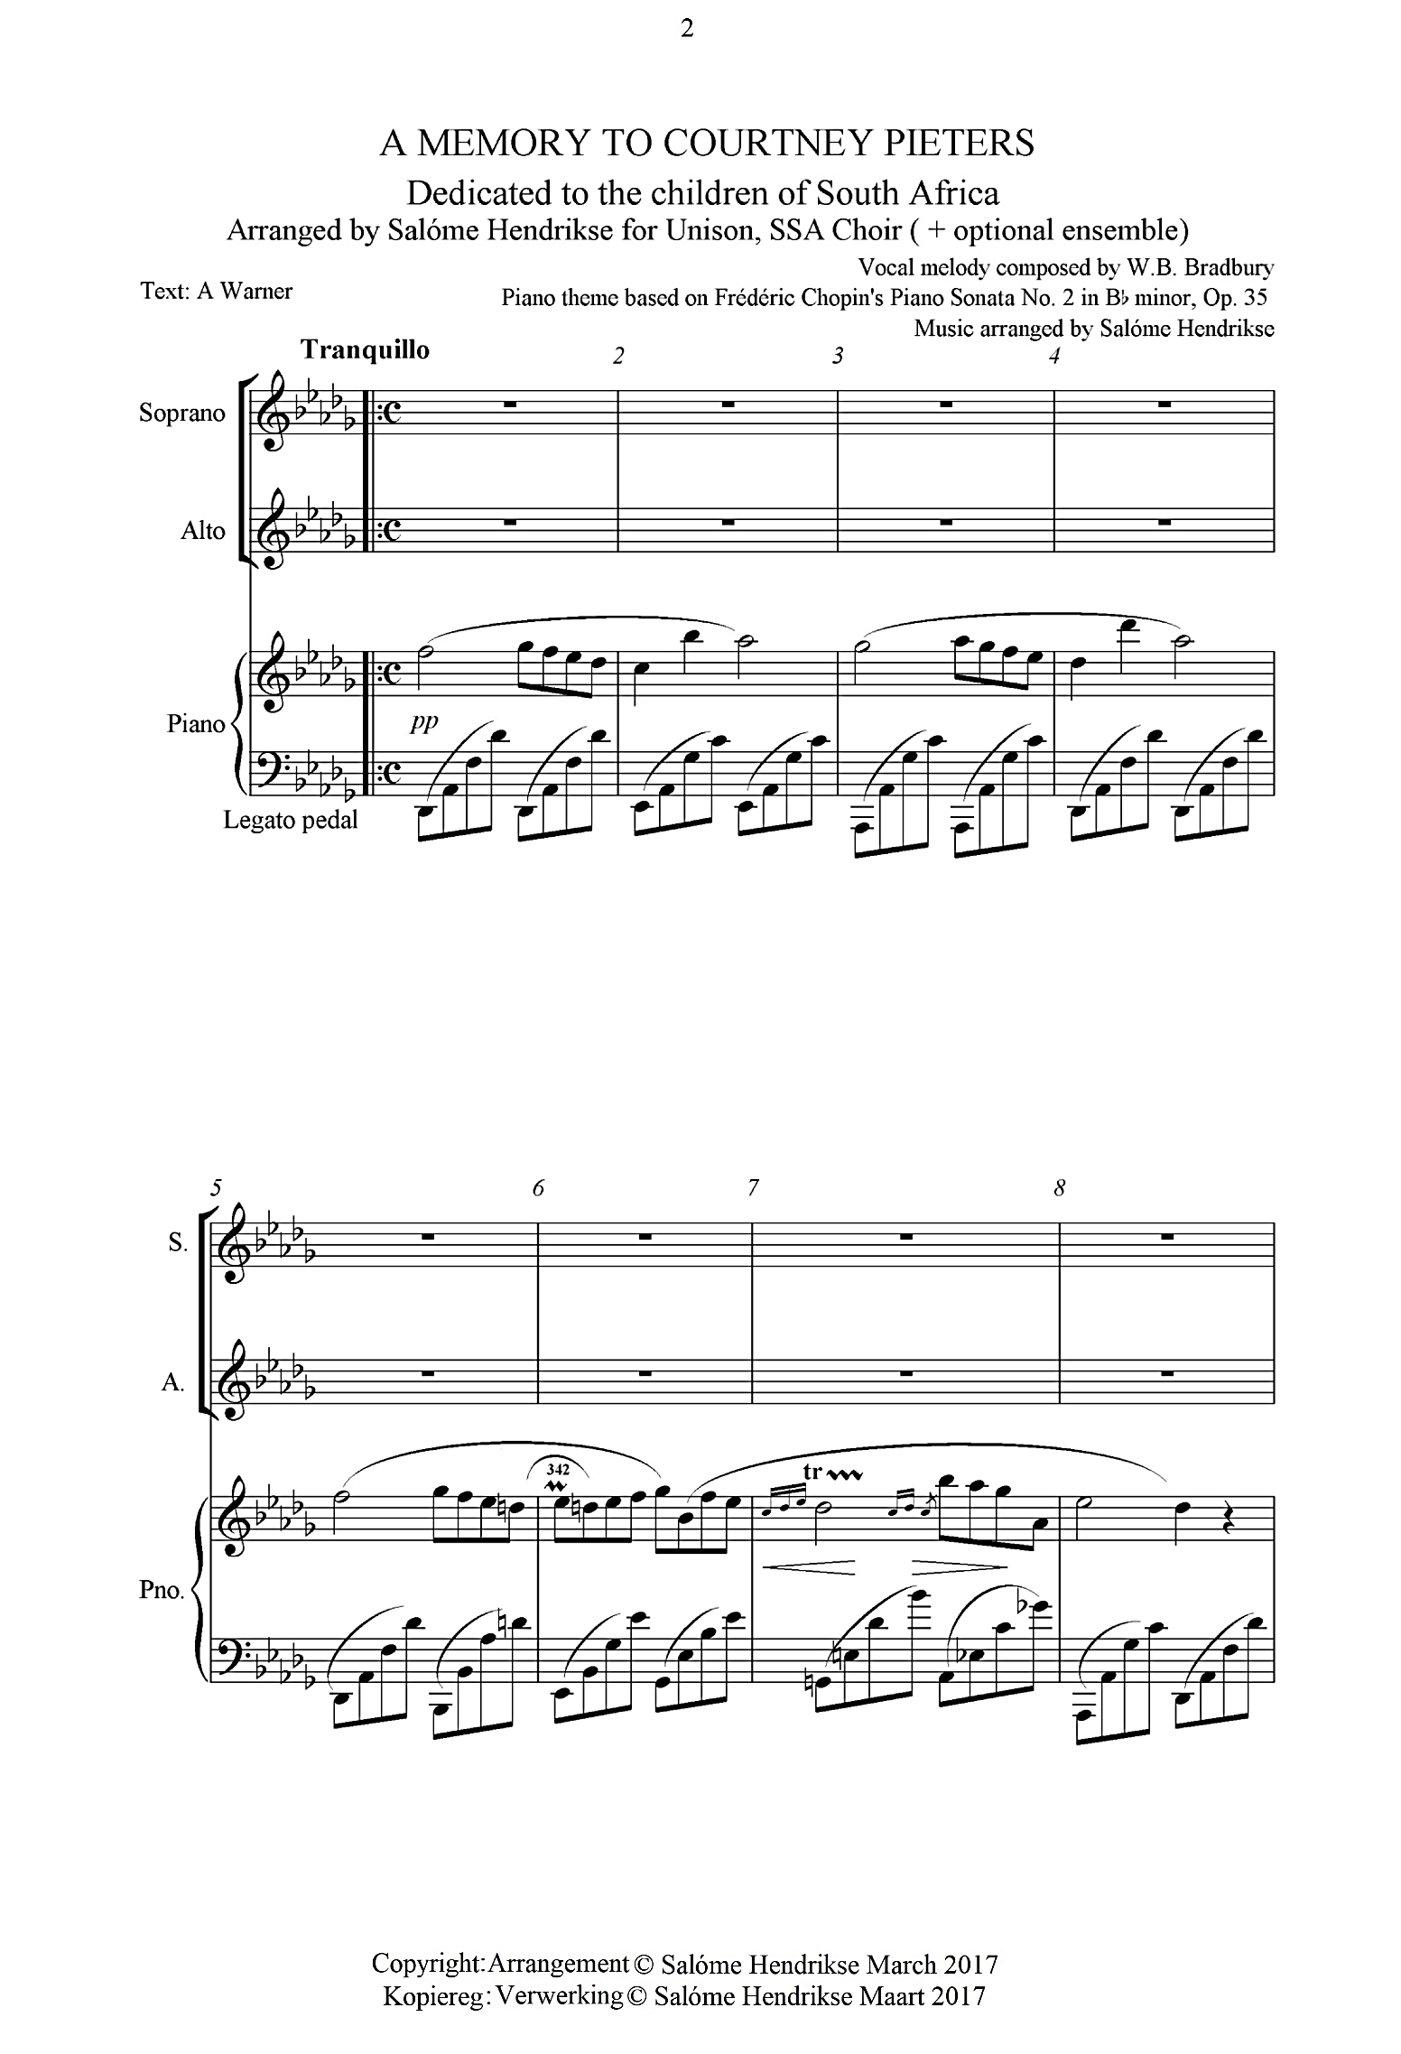

2

3

1

*Jubilate (“Vesper”)*

**Dedicated to Hannah Cornelius**

**Opgedra aan Hannah Cornelius**

And all women who were abused, raped, and murdered

En alle vroue wie mishandel, verkrag, en vermoor is

An arrangement for

Equal voice choirs, Soloist (Soprano / Tenor), and piano accompaniment

‘n Verwerking vir

Gelykstemmige kore, Solis (Sopraan of Tenoor), en klavierbegeleiding

Choral work / Koorwerk:

Integrated in this arrangement: *Russian Vesper*

Geïntigreer in die Verwerking: Russiese Aandgesang

*Bless this House* - Melody / Melodie: May Brahe

*Bless this House* - Text / Teks: Helen Taylor

*Ich Liebe dich*: Ludwig von Beethoven

Arrangement / Verwerking: Salóme Hendrikse

ISBN: 978 – 0 – 6399262 – 1 – 6

Copyright regarding the arrangement / Kopiereg tov die verwerking:

Salóme Hendrikse

4

5