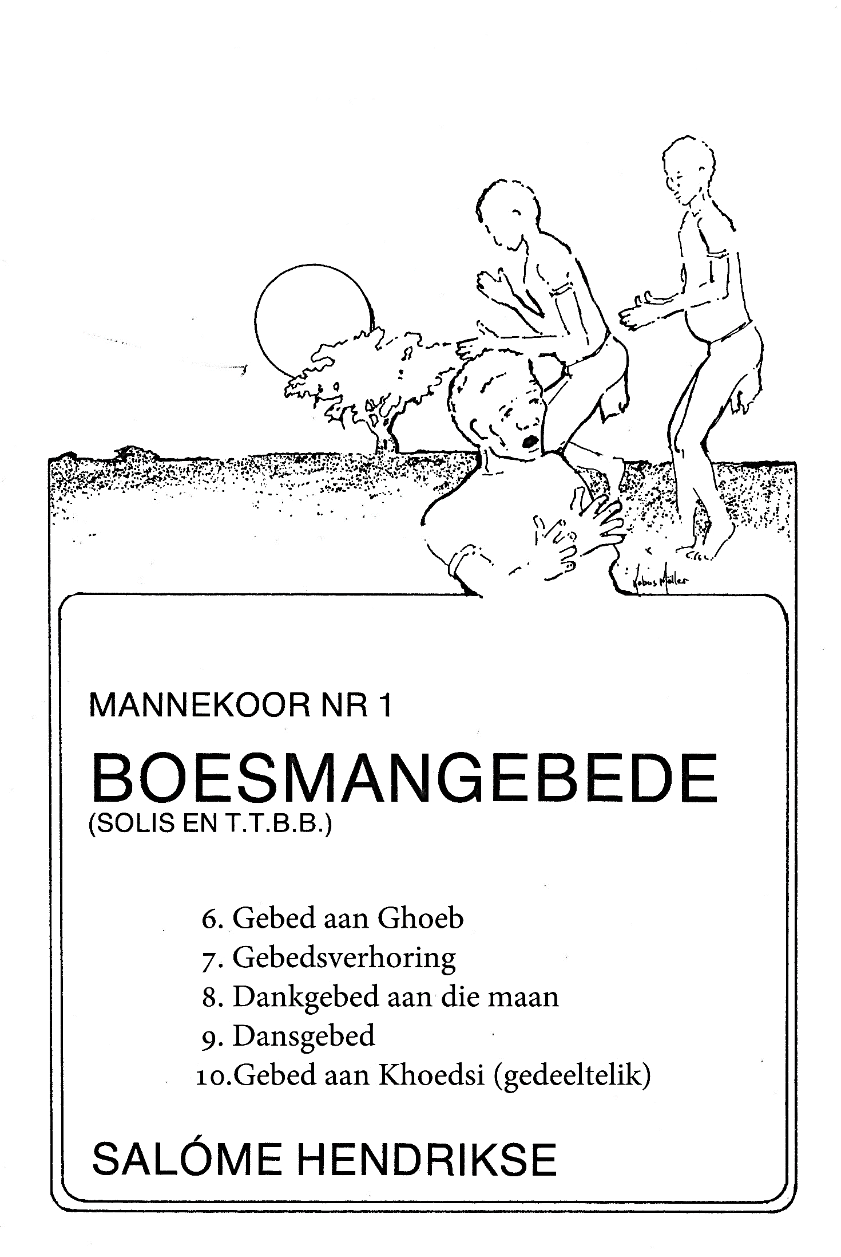

Uitreksels / Extracts:

