

Uittreksels / Extracts:

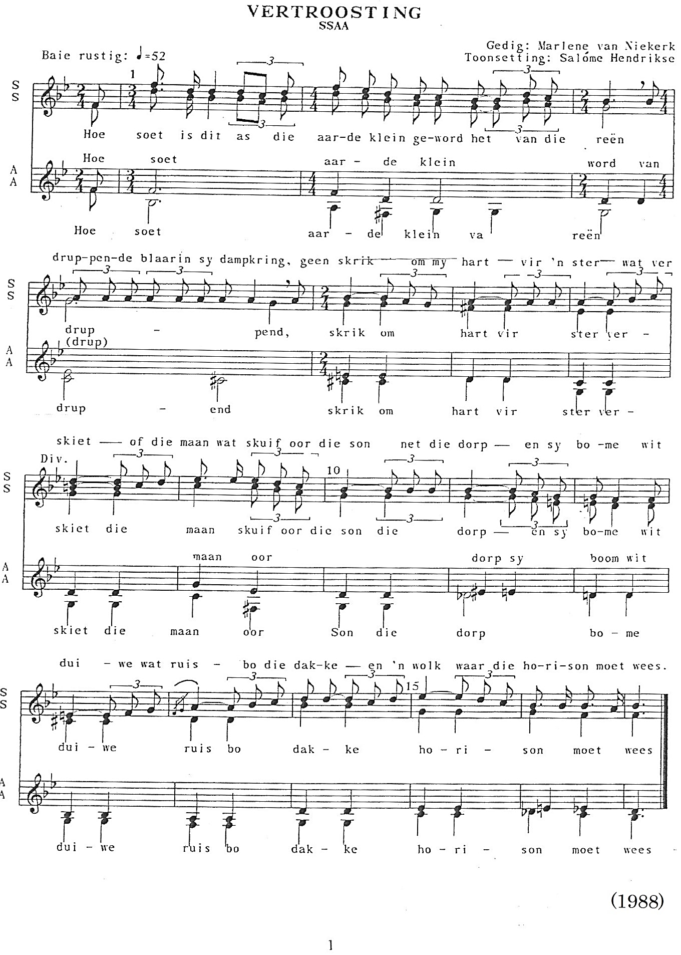

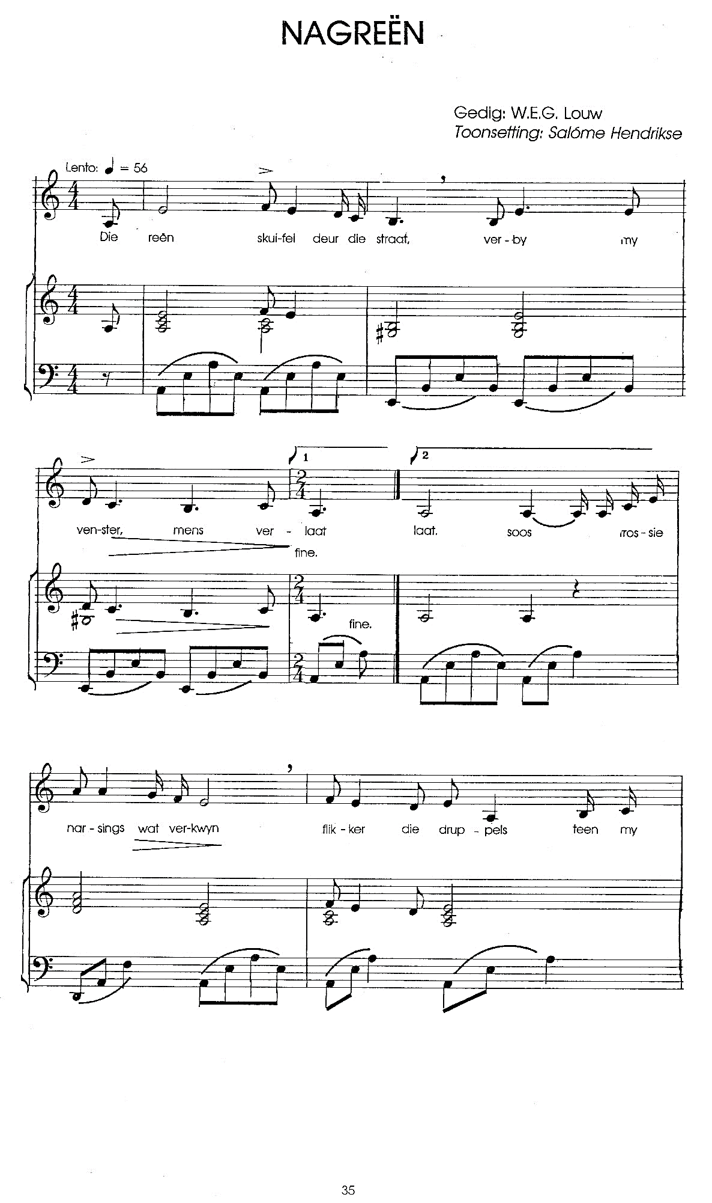

2

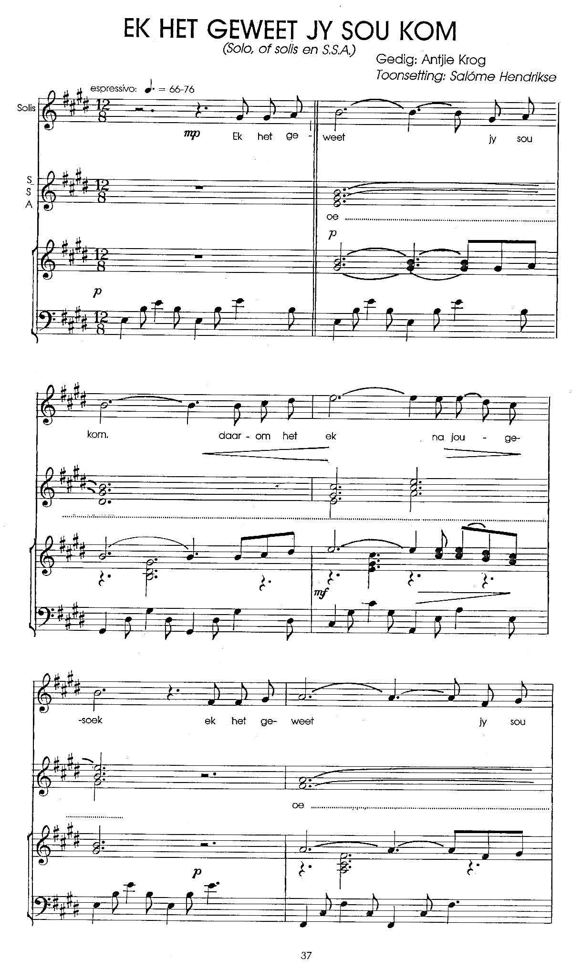

3

4

5

6

7

8

9

10